MAKINF FINS SECTION

STEP 1 : MAKE THE AIR FOIOL SECTION AND MIRROR ABT THE CENTER LINE IN FRONT PLANE

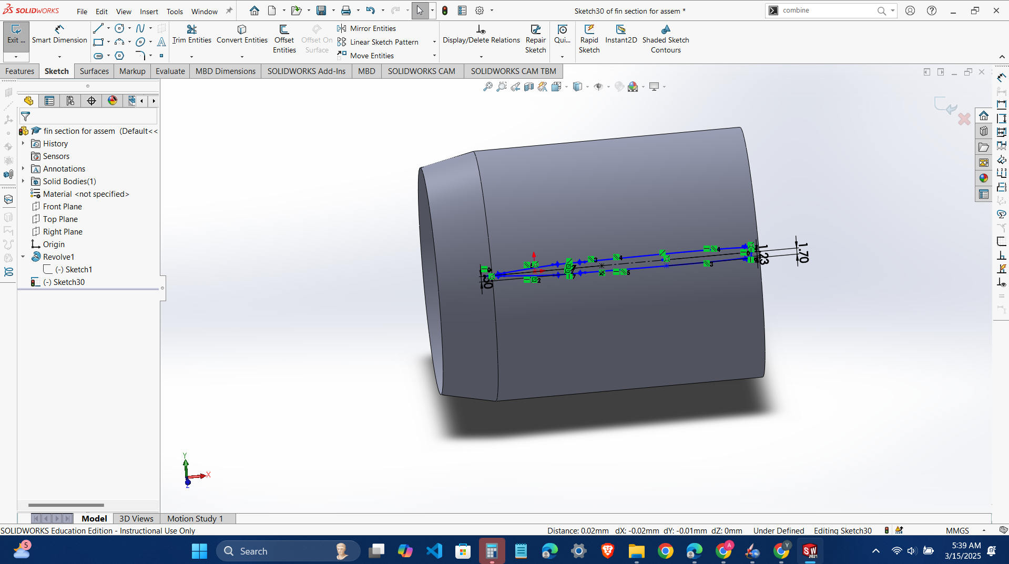

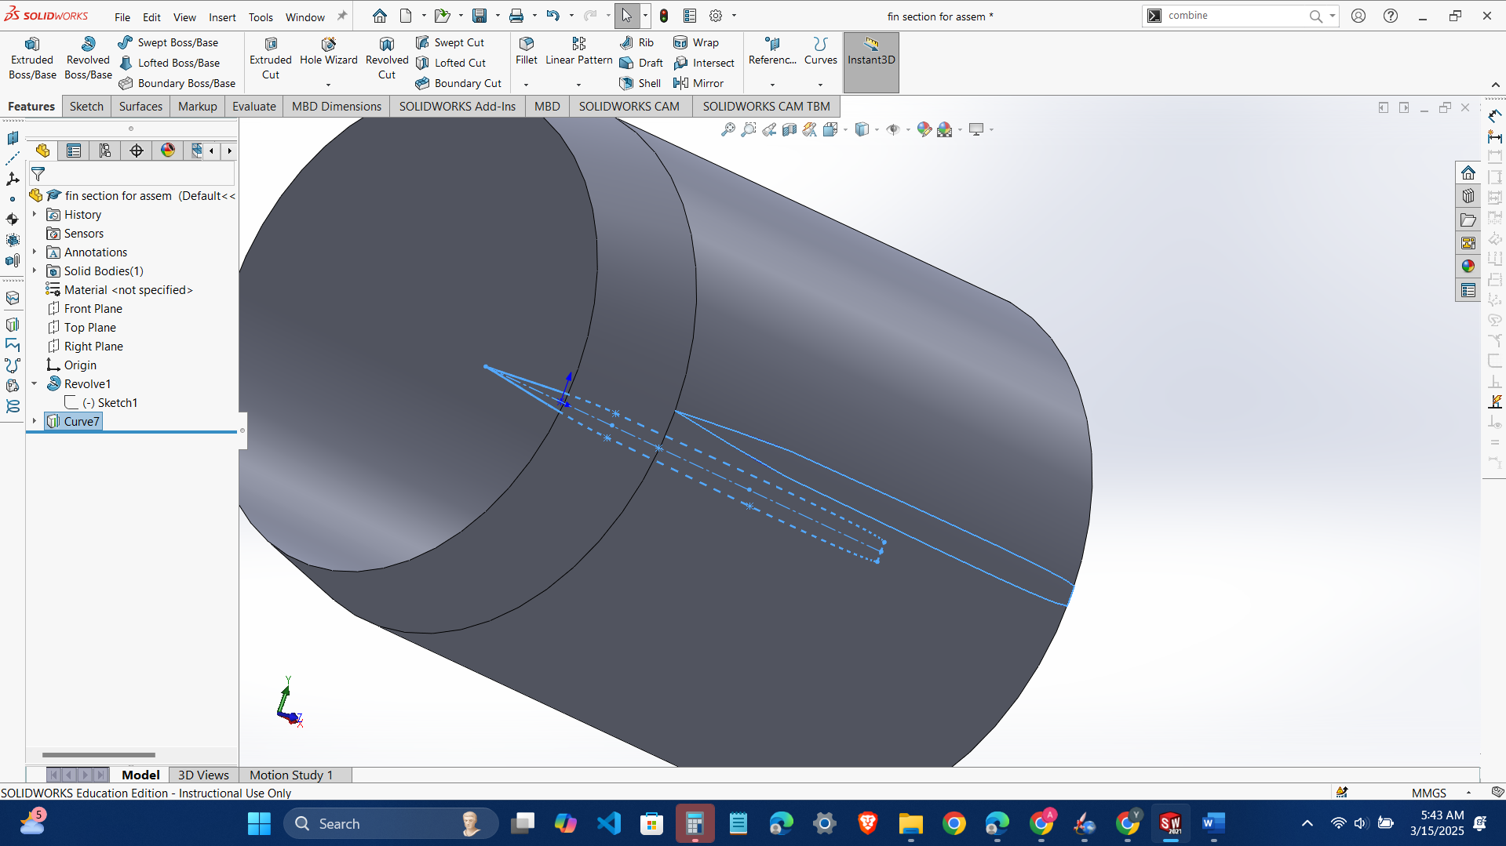

Make sure that its sharp in the front to reduce drag and both the edges up and down are related .

Three center lines and , bottom one collinear , second one over the second mid point and third one at the final mid point,

NEXT MAKE THE ACTUAL FIN SHAPE

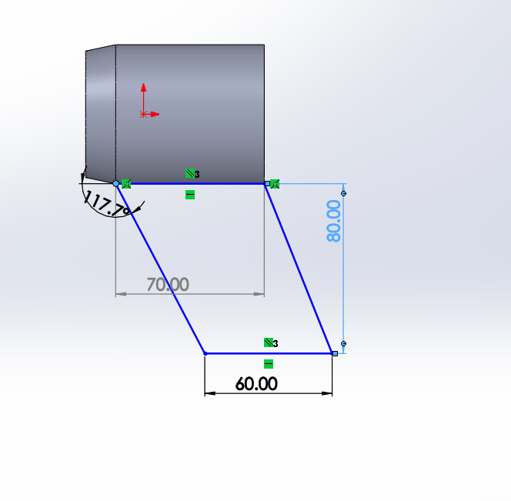give relations piere to the airfoil 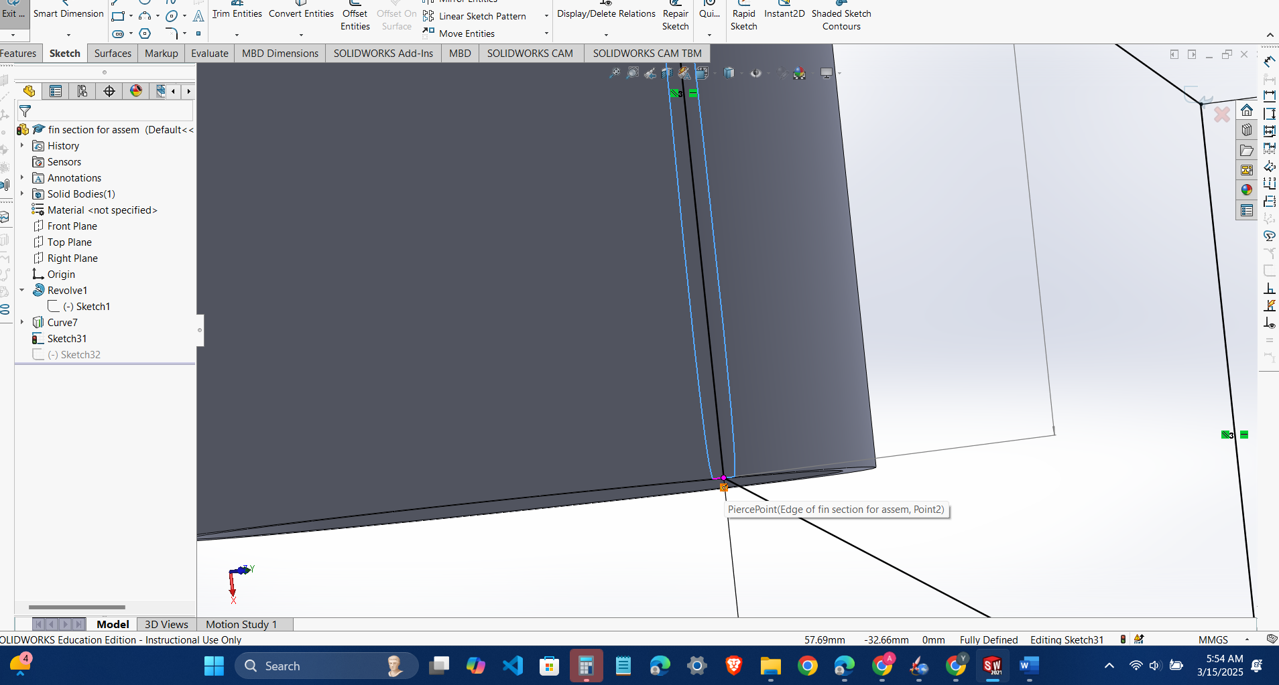

Delete that fucking edge or I think deselect the   
merge and fucking merge tangent options

Before completing the boss boundary thing,…….

Next circular pattern and later combine

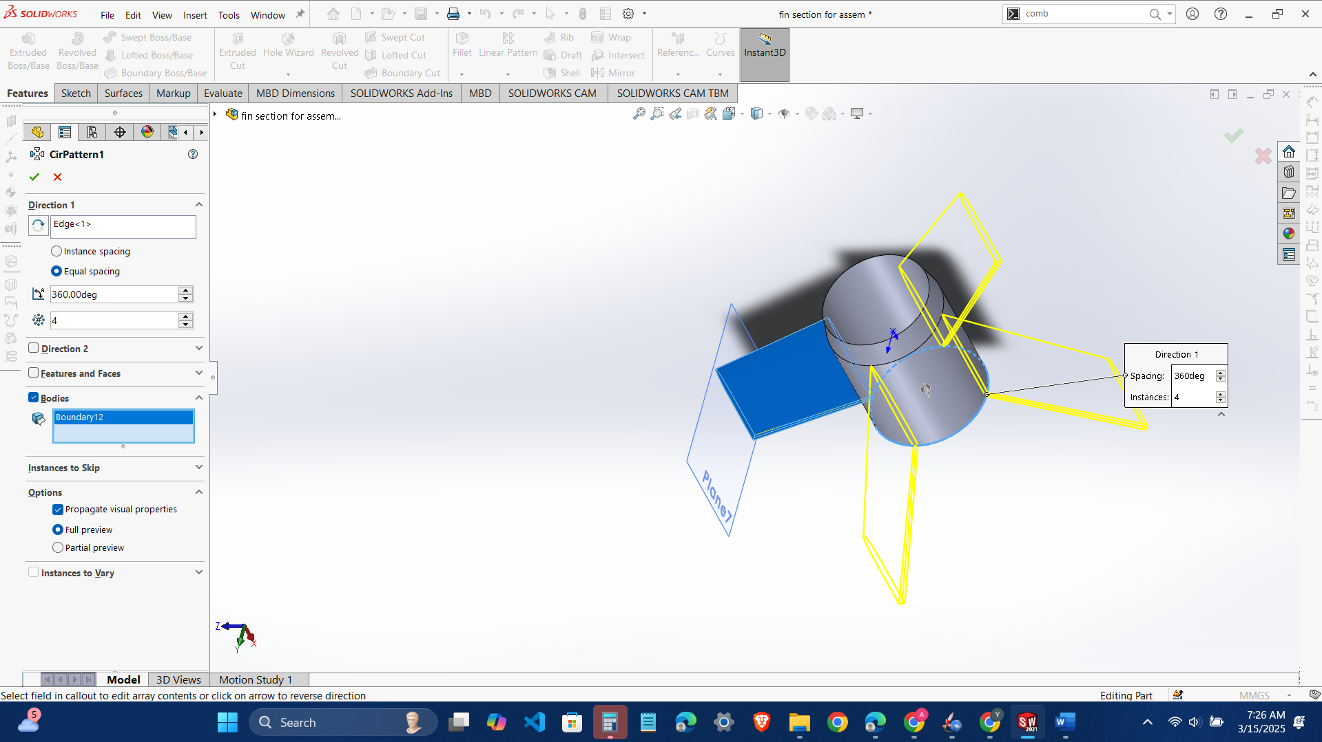

And now that fucking fillet

For curve fillet will not be possible use the other type of fillet for the curve , and select the two faces